[IS216] Extra Exercises - Week 3 - Bootstrap

Objectives
● To understand how the use of bootstrap enables styling of HTML elements
● To apply the use of bootstrap to HTML web pages.

Instructions
● Questions with no asterisk mark are easy peasy.
● Questions marked with * are slightly challenging.
● Questions marked with ** are challenging.
● Questions marked with *** are very challenging.

Download
● Resources: Click here
- Sample Solutions: Click here

NOTE: If you spot any mistakes/errors in the questions, please contact your instructors by email and state the issues. We will try to address it as soon as possible.

Question 1 – Fanpage (*)

#bootstrap
Resource: folder “fanpage\img” of images for the example below. You can use your own images.

Part 1. Create a fan page for your favourite k-pop group
- Menu
  - Home
    - Carousel of photos of the members.
  - Profiles
    - Cards of members’ profiles
    - Must be responsive
  - Link to youtube channel
  - Link to Instagram page

Example:
- Home
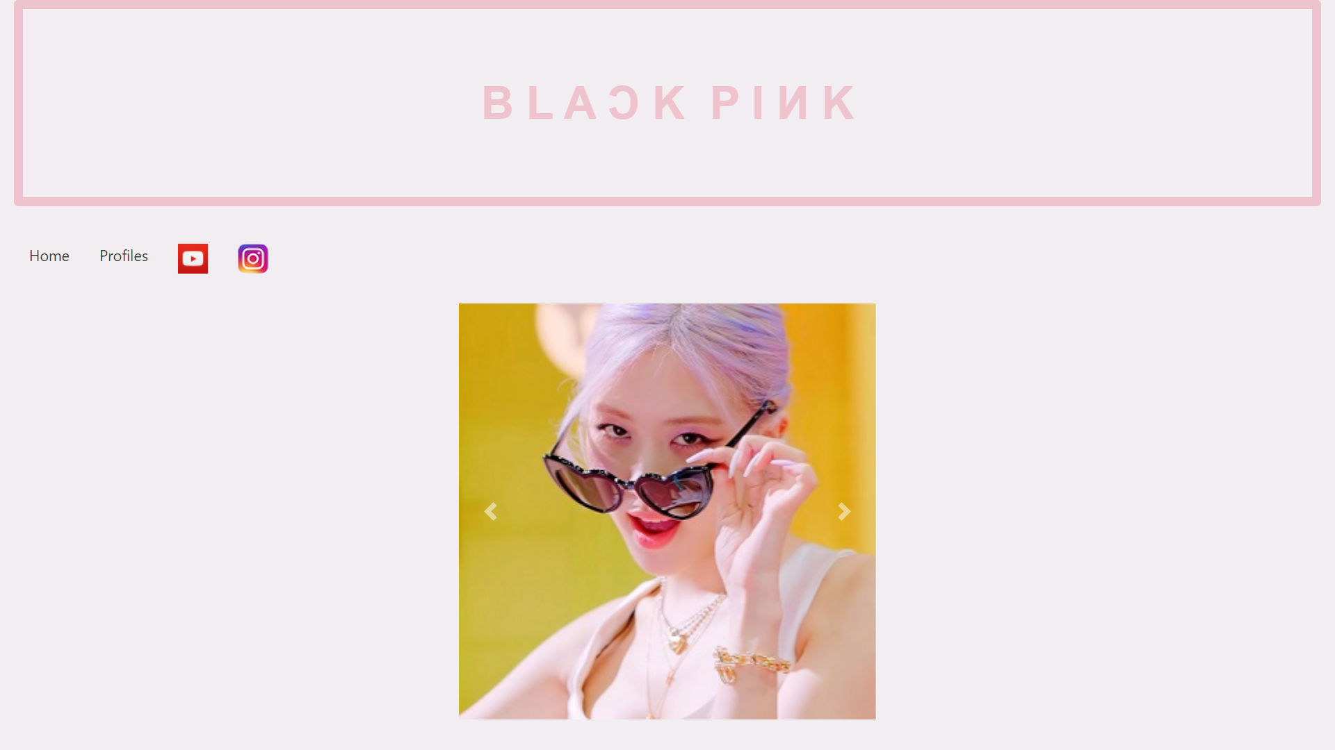
- Profile
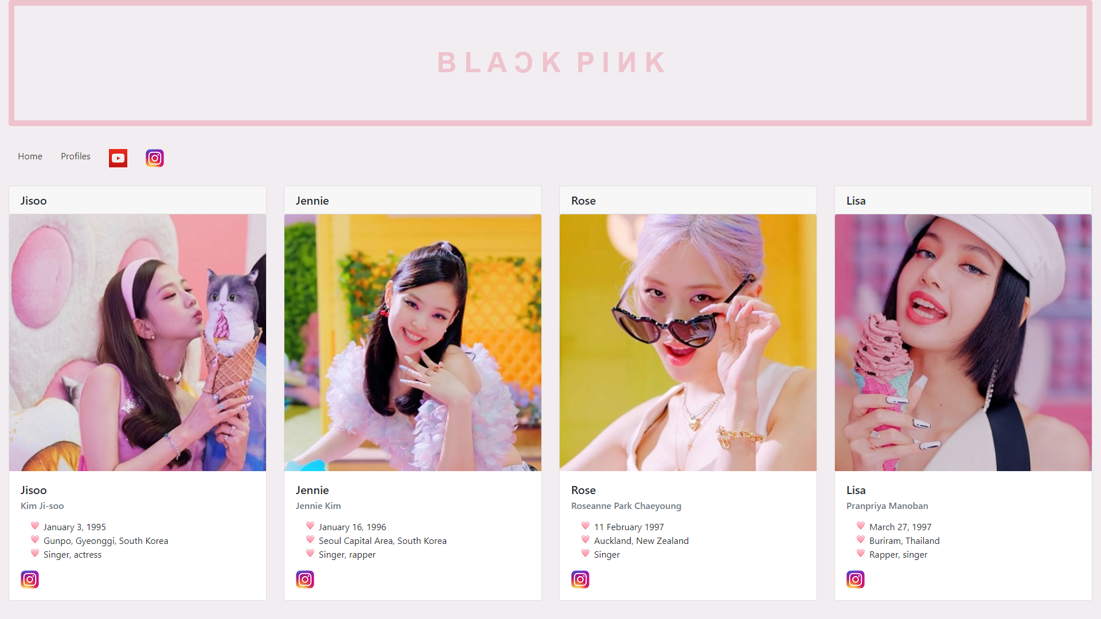
  - When viewed on screen whose width is smaller than md, the cards are stacked vertically.
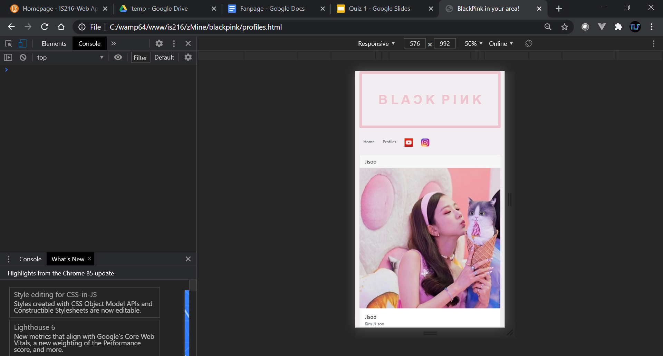

Part 2. Create another home page
- Vertical Menu
  - Link to youtube channel
  - Link to Instagram page
- Carousel of Cards of members’ profiles

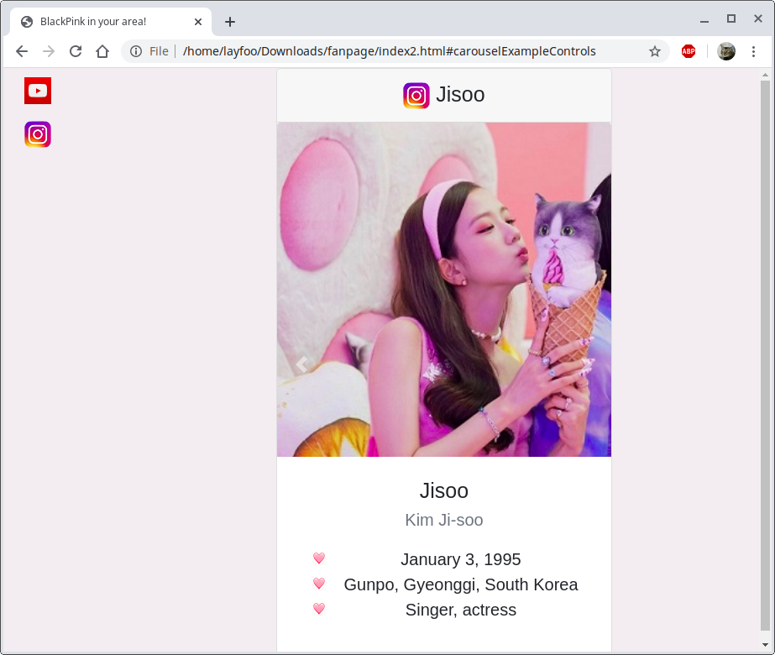

When viewed on screen whose width is smaller than sm
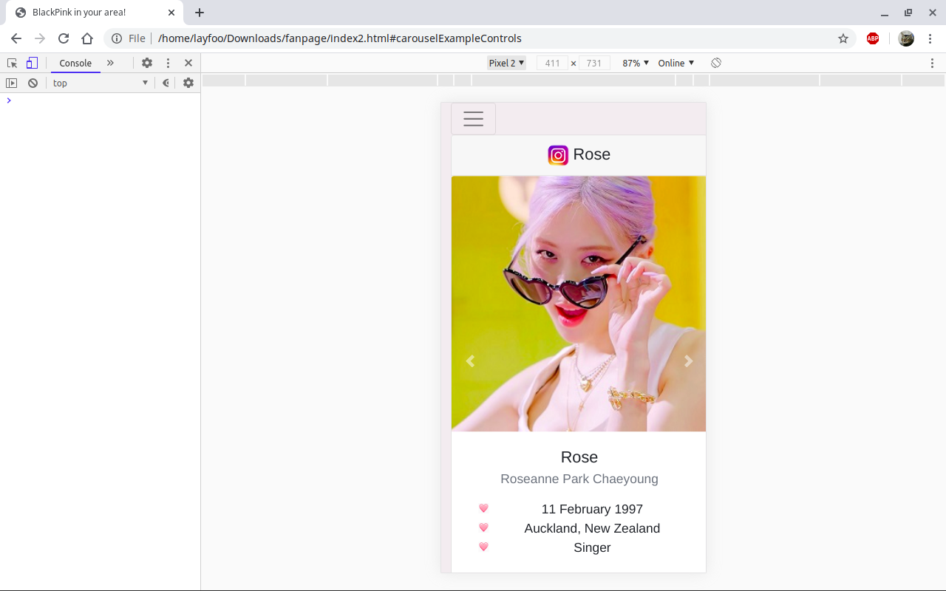 | When you click the hamburger  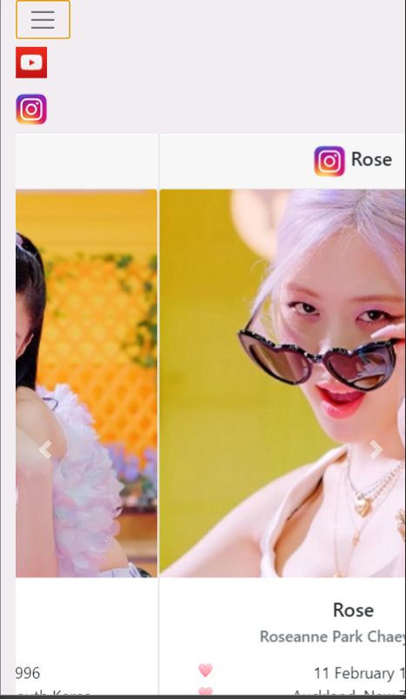

Question 2 – Registration Page (*)

Go to register directory.

|--register
|-- register.html

Complete register.html with appropriate CSS styling available from Bootstrap.com (getboostrap.com) such that the following responsive web page can be displayed on a web browser.

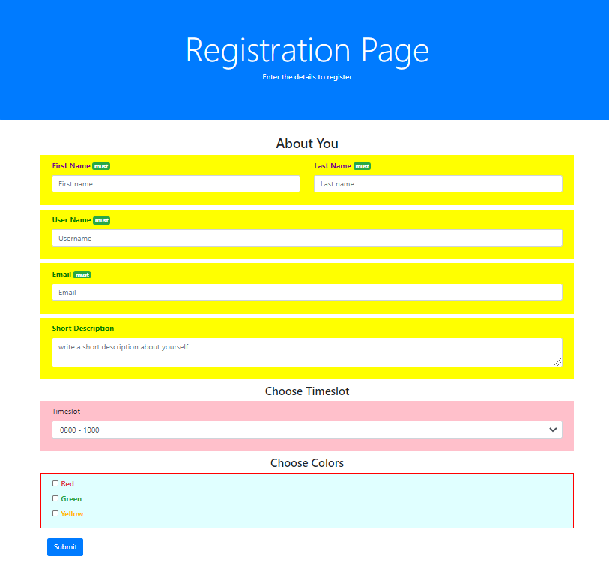

Question 3 – Food Mart (*)

Go to foodmart directory.

|--foodmart
|-- images
|-- <food pictures>
|-- foodmart.html

Complete foodmart.html with appropriate CSS styling available from Bootstrap.com (getboostrap.com) such that the following responsive web page can be displayed on a web browser as shown in Figure 1 and Figure 2.

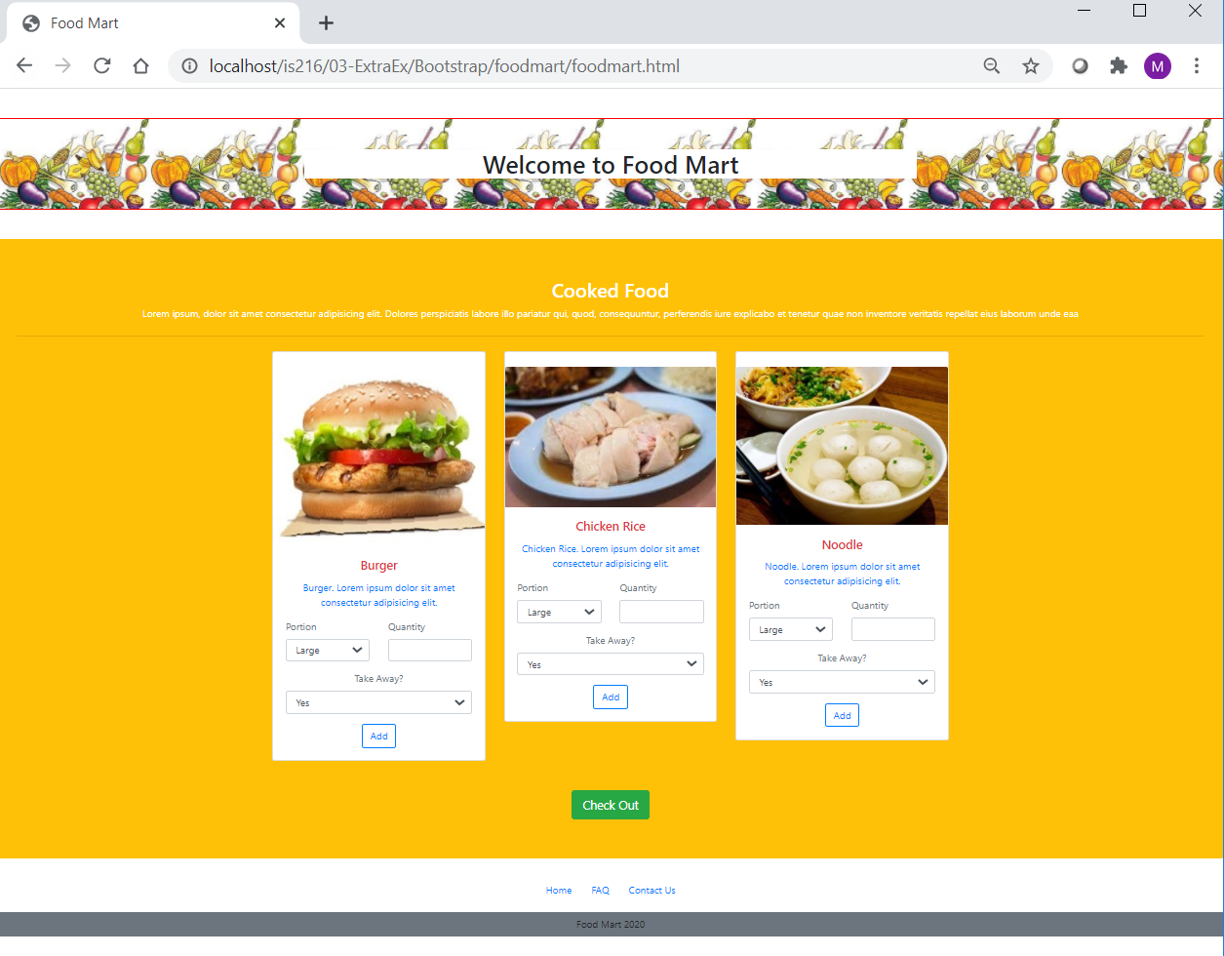
Figure 1: Full screen at 100%

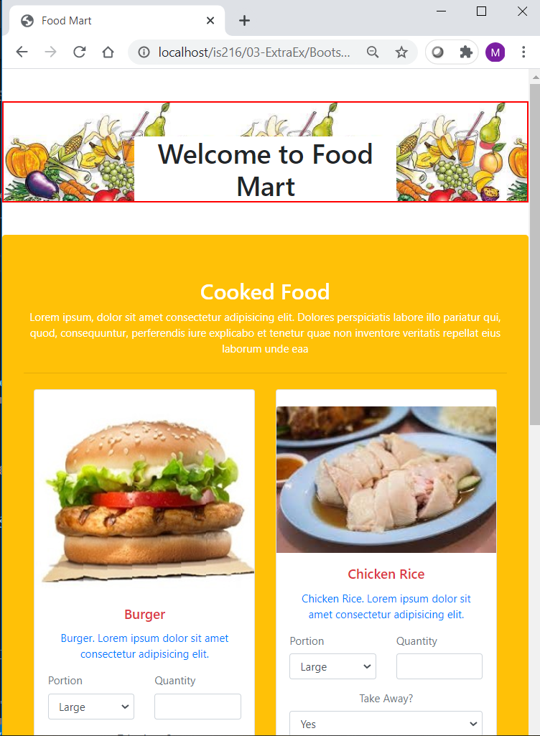

Figure 2: Web page display at a smaller viewpoint width

Question 4 – News (**)

Go to news directory.

|-- news
|-- img
|-- journalist.png, news.png, thumb_news.png
|-- news.html

Complete news.html with appropriate CSS styling available from Bootstrap.com (getboostrap.com) such that the following responsive web page can be displayed on a web browser as shown in the following Figure. Use minimal vanilla CSS.

